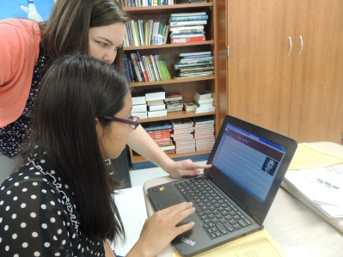
ENL Plus + is an English as a new language camp designed for secondary EL students in grades 6 -12.
- Teacher lead themed instruction.
- Integrated technology
- Individual and small group instruction
- Guest speakers from within our community
- Field-trips each week where students can apply the language taught in the classroom and make connections to our community through English.
Dates: June 10 –14 Week 1
June 17 – 21 Week 2

Time:
9:00 – 12:00 on Monday, Tuesday, Wednesday and Friday
9:00 – 1:00 on Thursdays (Field-trips)

Place: Carroll High School, Room TBD
Fees: There is no cost to attend. $0
Instructor:
Kayla Timmons ENL camp director
Kayla.Timmons@nacs.k12.in.us

To register, please complete the form on the back of this page and return to one of the above. Please return the form on or before April 30, 2019.

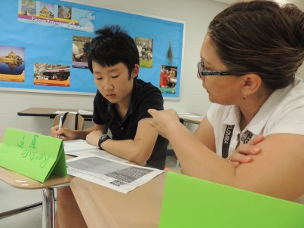

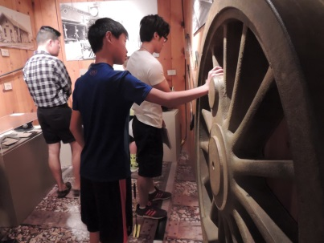
Registration Form  Student Name:  ___________________________  School and Grade:  ____________________________  Student Phone #  ____________________________  Birthday: _____/_____/________  Age ______  Allergies: ____________________  ____________________________  Parent/Guardian Contact Information  Name:  _______________________________  Address:  ___________________________  City, State, Zip  ____________________________  Home/Cell Phone  ___________________________________  Emergency Contact and Phone  ____________________________________  Yes/No I give permission for my child to be photographed during camp. (Photos may be used in future brochures.)  Registration forms are due by April 28. | Medical Release Form  (Complete, sign, and return with registration. Must be on file for camp.)  Participant___________________  Parent_______________________  Home phone #________________  Cell phone#__________________  Allergies_____________________  ____________________________  Preferred Doctor______________  Preferred Hospital_____________  In the event a parent/guardian cannot be reached, please list an emergency contact:  Name  ____________________________  Phone #  ____________________________  I hereby give my consent for physicians designated by school authorities and/or for transportation to a hospital emergency room for treatment for any illness or injury resulting from participation. I understand this authorization will only be enforced when I cannot be personally contacted to provide immediate treatment.  Parent/Guardian:  ________________________________  Date ____________________________

